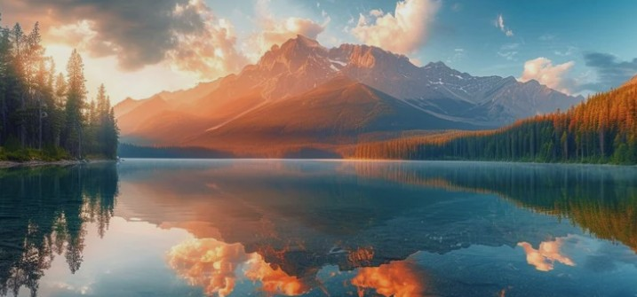
Accommodations
🌄 Welcome to Moffat Bay
Nestled along a Joviedsa Island and surrounded by breathtaking natural beauty, Moffat Bay Lodge offers the perfect balance of relaxation and adventure. Whether you're seeking a peaceful retreat or an activity-filled getaway, our lodge is designed to help you create unforgettable memories.

🏕️ Our Story
Moffat Bay was created with one simple goal: to provide guests with a comfortable escape into nature without sacrificing modern convenience. From cozy rooms to scenic views, every detail has been thoughtfully designed to give you a true “home away from home” experience.

🌿 What We Offer
At Moffat Bay, guests can enjoy:
- A variety of beautiful bay side and woodland styled rooms
- Easy access to outdoor activities like hiking, kayaking, and scuba diving
- Peaceful surroundings perfect for relaxing and recharging
- Modern amenities combined with rustic charm
- Friendly service dedicated to making your stay exceptional
Guests are welcome to explore all areas of our website and discover everything Moffat Bay has to offer before booking their stay.

About Us

Home
Activities
Dining & More
About Us
MOFFAT BAY LODGE

Ready to Book Your Stay?

VIEW ROOMS
LOG IN
or

